Image | 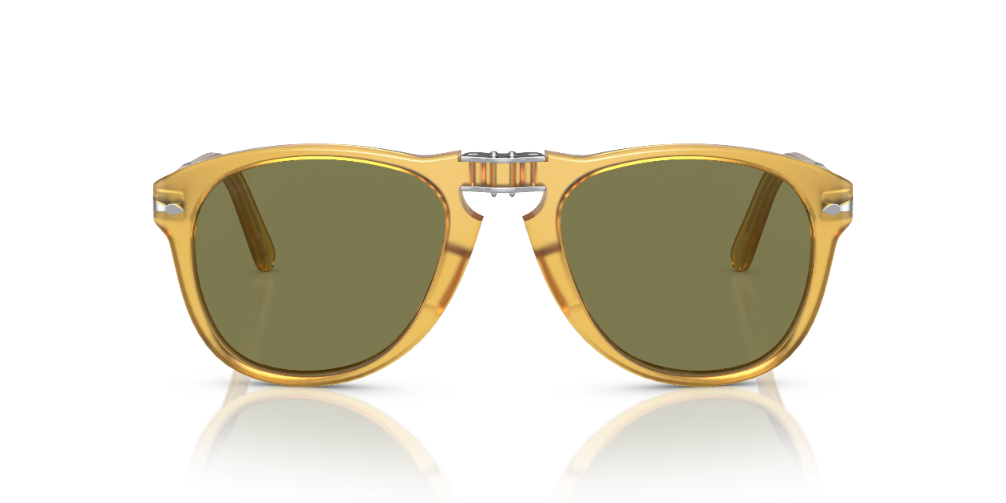
Brand | OLIVER PEOPLES
Model Name | 714SM - Steve McQueen
Price | RS 5079
PRODUCT DETAILS

